Project Report
Implement Client Script & UI Policy (Incident)
Date | 1 October 2026
Team ID | SWTID-2026-5148
Project Name | Implement Client Script & UI Policy (Incident)
Team Size | 4
Team Members | Mathangi S (Team Leader)  Meena Varshini T P  Mirthika R  Muthu Priya U

Project Report Format
1. INTRODUCTION
1.1 Project Overview
1.2 Purpose
2. IDEATION PHASE
2.1 Problem Statement
2.2 Empathy Map Canvas
2.3 Brainstorming
3. REQUIREMENT ANALYSIS
3.1 Customer Journey map
3.2 Solution Requirement
3.3 Data Flow Diagram
3.4 Technology Stack
4. PROJECT DESIGN
4.1 Problem Solution Fit
4.2 Proposed Solution
4.3 Solution Architecture
5. PROJECT PLANNING & SCHEDULING
5.1 Project Planning
6. FUNCTIONAL AND PERFORMANCE TESTING
6.1 Performance Testing
7. RESULTS
7.1 Output Screenshots
8. ADVANTAGES & DISADVANTAGES
9. CONCLUSION
10. FUTURE SCOPE
11. APPENDIX
Source Code (if any)
Dataset Link
GitHub & Project Demo Link

1. INTRODUCTION

1.1 Project Overview
Incident records need consistent and accurate data for effective triage, routing and resolution. Relying only on user awareness and manual checks can lead to incomplete, inconsistent or incorrect data being submitted, which affects reporting accuracy, SLA compliance and service quality.
The Implement Client Script & UI Policy (Incident) project shows how ServiceNow client-side controls can be used to enforce data integrity directly on the Incident form. A UI Policy and three Client Scripts (onChange, onSubmit and onCellEdit) control field behaviour, auto-populate values and prevent record submission when the required conditions are not met.

1.2 Purpose
The purpose of the project is to ensure that Incidents are created with complete and valid information by enforcing conditional field behaviour and validation at the user-interface level, improving data quality and consistency across the platform. Skills used: Incident Management, UI Policy, UI Policy Actions, Client Scripts and Form Validation.

2. IDEATION PHASE

2.1 Problem Statement
Three customer problem statements were defined using the "I am / I'm trying to / But / Because / Which makes me feel" format.
PS | I am (Customer) | I'm trying to | But | Because | Which makes me feel
PS-1 | a service desk agent who logs and triages Incidents in ServiceNow | submit complete and accurate Incident records, especially High-impact ones | Assigned To / Assignment group and Urgency are often left blank or inconsistent when the record is saved | the Incident form has no conditional rules and depends on users manually remembering to check fields | stressed and worried about SLA breaches and wrong routing
PS-2 | an ITSM manager responsible for Incident reports and SLA compliance | rely on accurate Incident data to track priority, routing and resolution | High-impact incidents are saved with a low or mismatched Urgency and incomplete assignment details | Urgency is entered manually and is not tied to Impact by any automatic rule | concerned and unable to trust reports
PS-3 | a ServiceNow administrator who owns data quality on the Incident table | make sure users cannot bypass form validations | users can change the State field directly from the list view, skipping the form-level rules | list editing is not covered by form UI Policies or onSubmit scripts | worried and not in control of data integrity

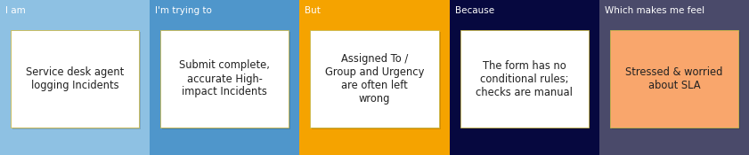
Figure 2.1: Problem statement PS-1

2.2 Empathy Map Canvas
Empathy maps were created for the two main users: the service desk agent and the ITSM manager / process owner.
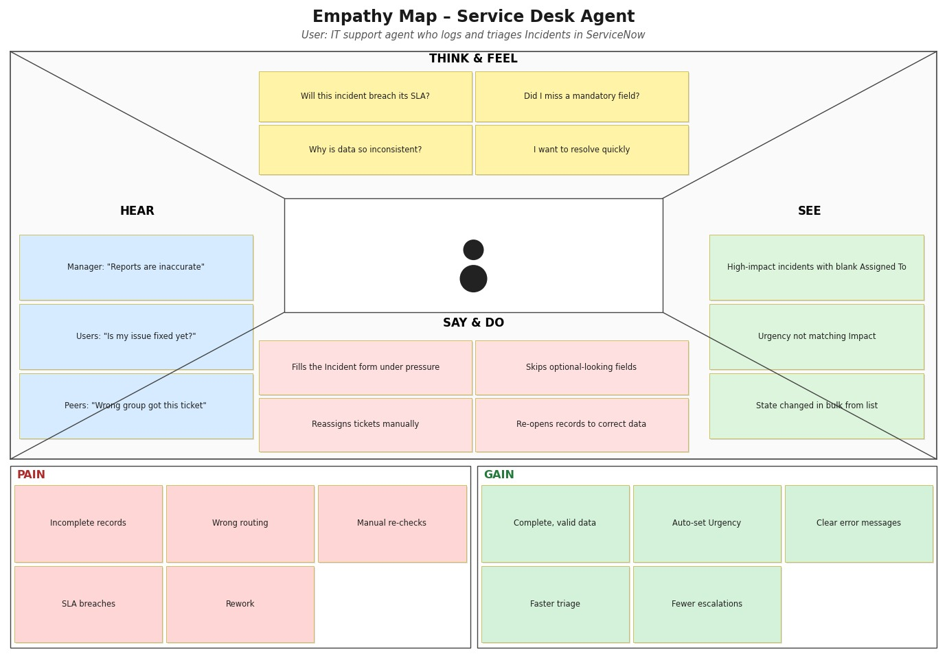
Figure 2.2: Empathy map – Service Desk Agent
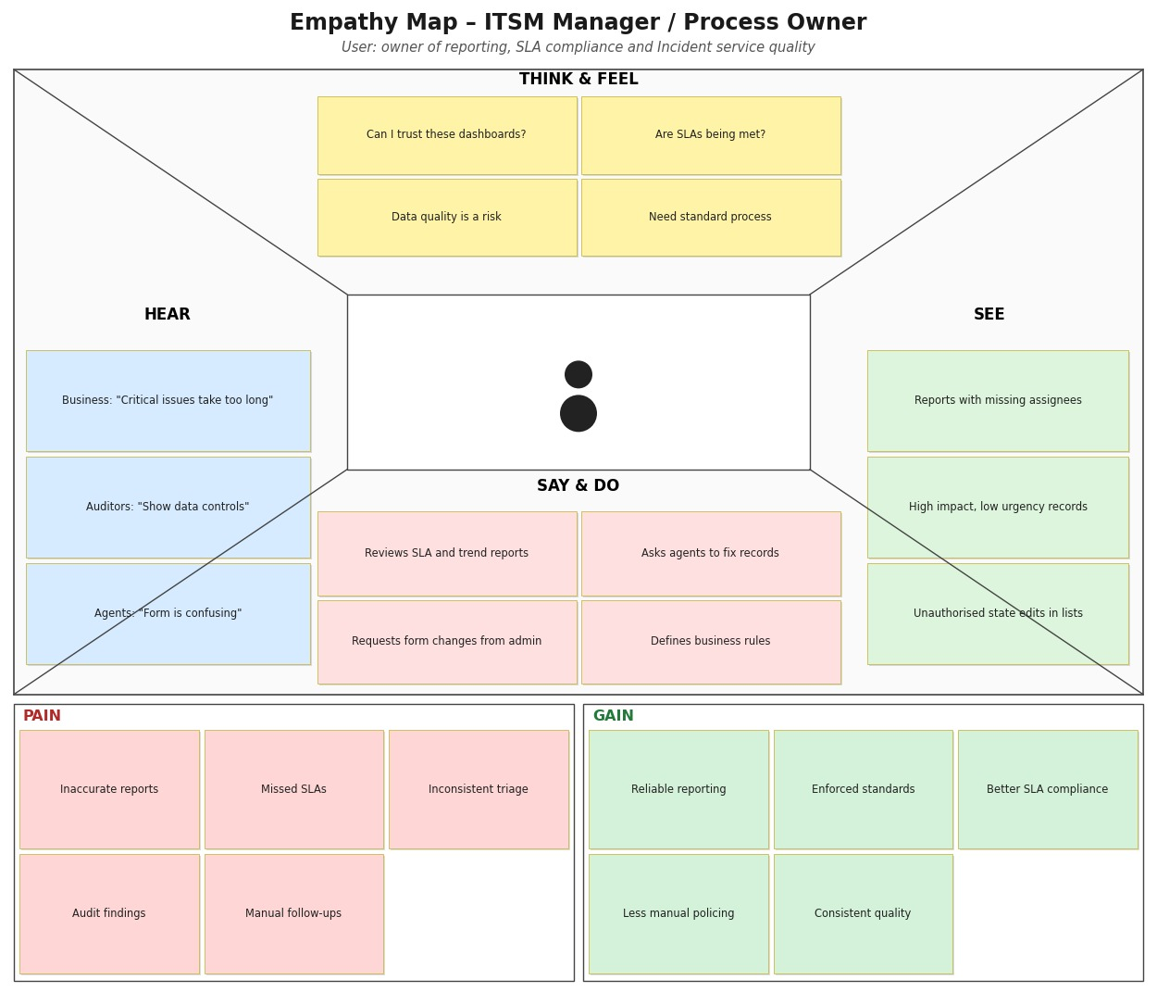
Figure 2.3: Empathy map – ITSM Manager / Process Owner

2.3 Brainstorming
The team gathered, selected the problem statement, listed and grouped ideas, and prioritised them by importance and feasibility.
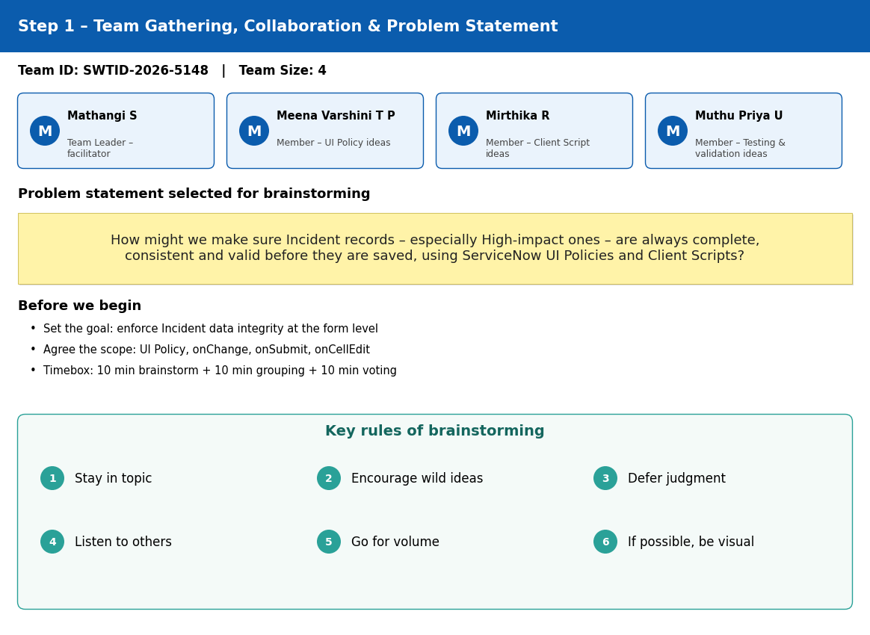
Figure 2.4: Step 1 – Team gathering and problem statement
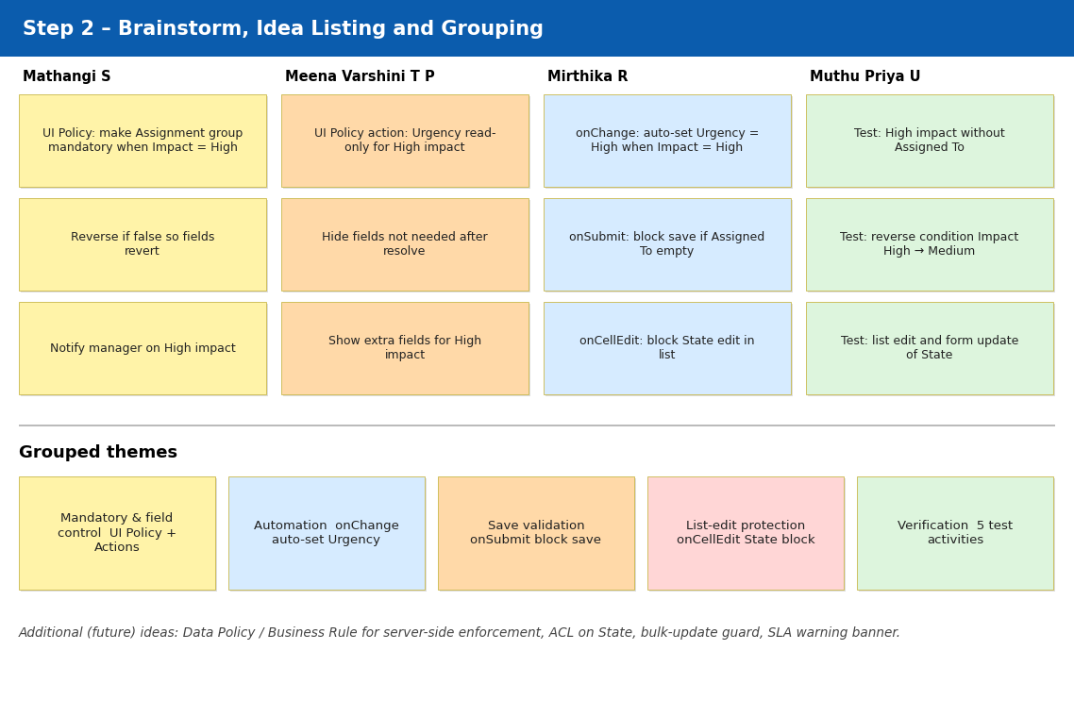
Figure 2.5: Step 2 – Brainstorm, idea listing and grouping
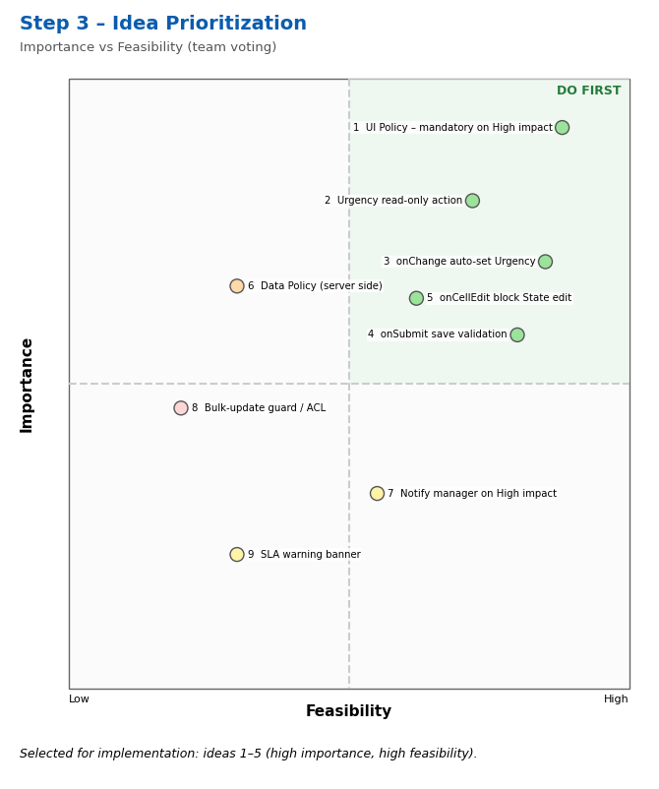
Figure 2.6: Step 3 – Idea prioritisation
Idea | Importance | Feasibility | Decision
1. UI Policy – Assignment group mandatory when Impact = High (Reverse if false) | High | High | Implement
2. UI Policy Action – Urgency read-only for High impact | High | High | Implement
3. onChange Client Script – auto-set Urgency = High | High | High | Implement
4. onSubmit Client Script – block save if Assigned To is empty | High | High | Implement
5. onCellEdit Client Script – block State edit from list view | Medium-High | High | Implement
6. Data Policy / Business Rule for server-side enforcement | High | Medium | Future scope
7. Notify manager on High-impact incidents | Medium | Low | Future scope
8. Bulk-update guard / ACL on State | Medium-High | Low | Future scope
9. SLA warning banner on the form | Low | Low | Not selected

3. REQUIREMENT ANALYSIS

3.1 Customer Journey map
The journey of the service desk agent logging, validating, saving and updating a High-impact Incident is shown across the stages Entice, Enter, Engage, Exit and Extend (landscape page).

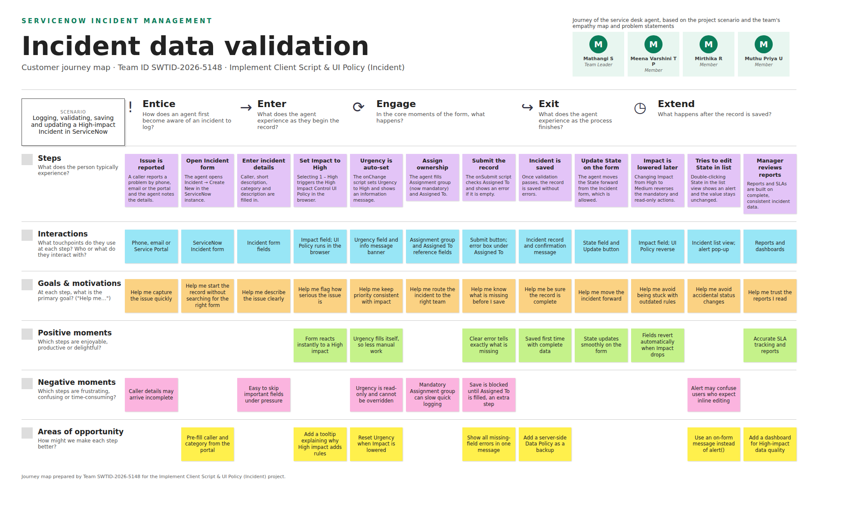
Figure 3.1: Customer journey map – Incident data validation

3.2 Solution Requirement
Functional requirements:
FR No. | Functional Requirement (Epic) | Sub Requirement (Story / Sub-Task)
FR-1 | Conditional Field Control (UI Policy) | High Impact Control UI Policy on Incident / Condition: Impact is 1 – High / Assignment group becomes mandatory / Reverse if false
FR-2 | UI Policy Action – Urgency | Urgency set to read-only when the condition is met / Visible left unchanged / Field returns to editable when the condition is not met
FR-3 | Auto-population (onChange Client Script) | Runs when Impact changes / Sets Urgency to 1 – High when Impact = High / Shows an information message
FR-4 | Save-time Validation (onSubmit Client Script) | Checks Assigned To when Impact = High / Shows an error on the field and stops the save / Allows save when valid
FR-5 | List-edit Restriction (onCellEdit Client Script) | Monitors the State field in the list view / Shows an alert / Cancels the edit so State remains unchanged
FR-6 | Form-based Updates | State can still be changed on the Incident form / Other fields keep following the UI Policy and Client Script rules
FR-7 | Configuration & Testing | Create policies and scripts under System UI / Run test activities: mandatory enforcement, successful save, reverse condition, list-edit blocking, form update

Non-functional requirements:
NFR No. | Non-Functional Requirement | Description
NFR-1 | Usability | Clear, short messages (info message, field error, alert) guide the agent; mandatory and read-only fields are visibly marked on the form.
NFR-2 | Security | Configuration is limited to users with administrative access; the form is accessed over the platform's role-based, authenticated session. Client scripts support, but do not replace, server-side enforcement.
NFR-3 | Reliability | Rules are applied consistently every time the Impact field changes or a record is submitted; Reverse if false restores the fields correctly.
NFR-4 | Performance | Validations run in the browser through lightweight scripts, with no extra server round trip for the checks.
NFR-5 | Availability | The solution runs on the ServiceNow cloud instance and is available whenever the instance is available.
NFR-6 | Scalability | Policies and scripts are defined once on the Incident table and apply to all Incident records and users without extra setup.

3.3 Data Flow Diagram
Level 0 and Level 1 data flow diagrams show how incident data moves between the users, the validation process and the Incident table.
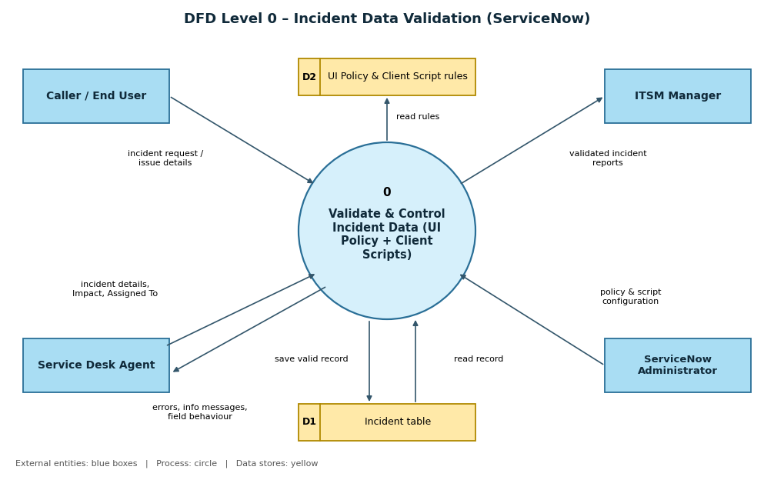
Figure 3.2: DFD Level 0
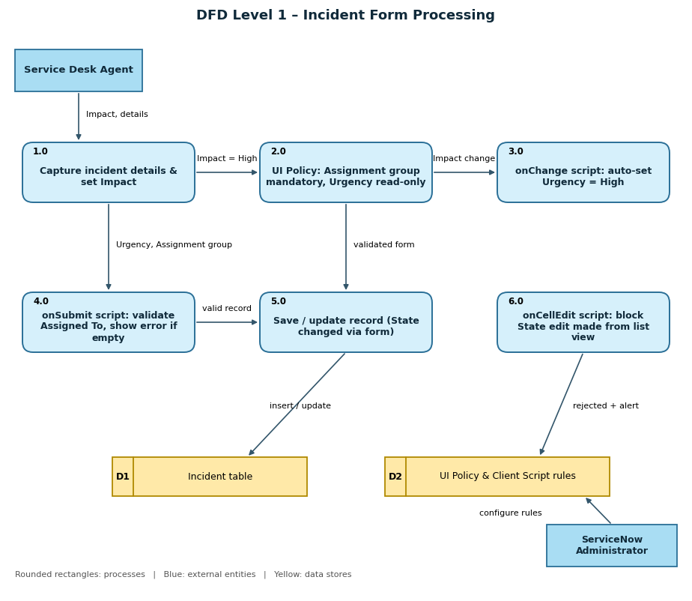
Figure 3.3: DFD Level 1
User stories:
User Type | Functional Requirement (Epic) | User Story No. | User Story / Task (summary) | Priority | Release
Service Desk Agent | Incident Creation & Impact Handling | USN-1 | Set Impact to High so the system applies extra controls | High | Sprint-1
 |  | USN-2 | Provide Assignment group when Impact is High | High | Sprint-1
 |  | USN-3 | Urgency set automatically to High when Impact is High | High | Sprint-1
 |  | USN-4 | Urgency read-only while Impact is High | Medium | Sprint-1
 | Save Validation | USN-5 | Prevented from saving a High-impact Incident without Assigned To | High | Sprint-2
 |  | USN-6 | Save the Incident once Assigned To is filled | High | Sprint-2
 | Reverse Behaviour | USN-7 | Extra controls removed when Impact changes from High to Medium | Medium | Sprint-2
 | State Update | USN-8 | Change State on the Incident form | High | Sprint-2
ITSM Manager | Data Quality & Control | USN-9 | State changes from the list view are blocked | High | Sprint-2
 |  | USN-10 | Every High-impact incident has an assignee and group | Medium | Sprint-3
ServiceNow Administrator | Configuration | USN-11 | Create and activate the UI Policy and its actions | High | Sprint-1
 |  | USN-12 | Create onChange, onSubmit and onCellEdit Client Scripts | High | Sprint-1
 | Testing | USN-13 | Run the test activities to confirm behaviours | Medium | Sprint-3
Caller / End User | Incident Submission | USN-14 | High-impact issue reaches the support team with complete details | Medium | Sprint-3

3.4 Technology Stack
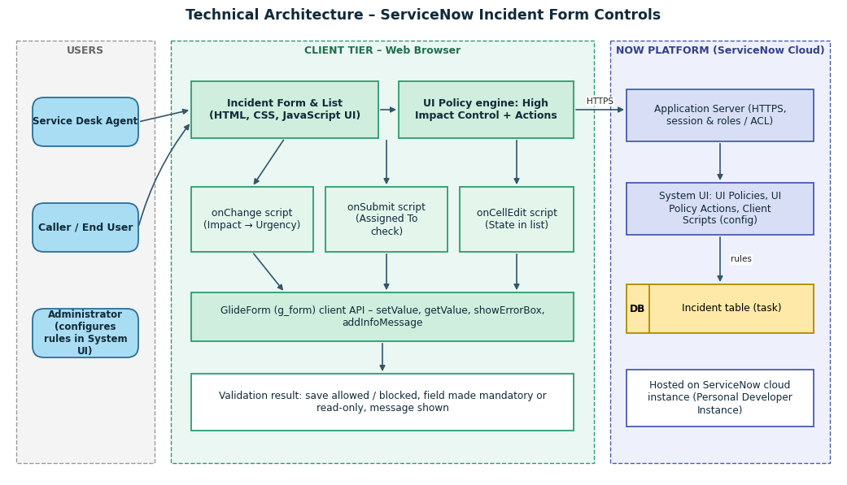
Figure 3.4: Technical architecture
Table 1: Components & Technologies
S.No | Component | Description | Technology
1 | User Interface | Incident form and list used by the agent | ServiceNow Incident form / list (HTML, CSS, JavaScript rendered by the platform)
2 | Application Logic-1 | UI Policy "High Impact Control": mandatory Assignment group and read-only Urgency when Impact = High | UI Policy and UI Policy Actions (System UI)
3 | Application Logic-2 | onChange Client Script: sets Urgency to High when Impact becomes High | JavaScript – GlideForm (g_form) API
4 | Application Logic-3 | onSubmit Client Script: blocks save when Assigned To is empty for High impact | JavaScript – g_form.showErrorBox
5 | Application Logic-4 | onCellEdit Client Script: blocks State edits made from the list view | JavaScript – onCellEdit callback
6 | Database | Incident table storing Impact, Urgency, Assignment group, Assigned To, State | ServiceNow relational database (managed by the platform)
7 | Cloud Database | Database service hosted in the ServiceNow cloud | ServiceNow cloud instance
8 | File Storage | Not required for this project | Not applicable
9 | External API-1 | Not used; the solution is platform-native | Not applicable
10 | External API-2 | Not used | Not applicable
11 | Machine Learning Model | Not used | Not applicable
12 | Infrastructure (Server / Cloud) | Deployment on a cloud-hosted ServiceNow instance managed by ServiceNow | ServiceNow Personal Developer Instance / cloud instance

Table 2: Application Characteristics
S.No | Characteristics | Description | Technology
1 | Open-Source Frameworks | No custom open-source framework; uses native ServiceNow low-code features | ServiceNow platform (JavaScript client API)
2 | Security Implementations | Role-based access and authenticated sessions over HTTPS; configuration limited to admin roles; server-side rules recommended as a future backup | ServiceNow roles / ACLs, HTTPS
3 | Scalable Architecture | Multi-tier platform (browser, application server, database); rules defined once on the table apply to all records | ServiceNow multi-tier cloud platform
4 | Availability | Cloud-hosted instance; availability handled by the ServiceNow platform | ServiceNow cloud
5 | Performance | Validations run in the browser with lightweight scripts, avoiding extra server calls | Client-side JavaScript, UI Policy

4. PROJECT DESIGN

4.1 Problem Solution Fit
The Problem-Solution Fit canvas confirms that the solution (UI Policy and Client Scripts) fits the customer segments, their constraints and behaviour, and addresses the root causes of incomplete and inconsistent Incident data.
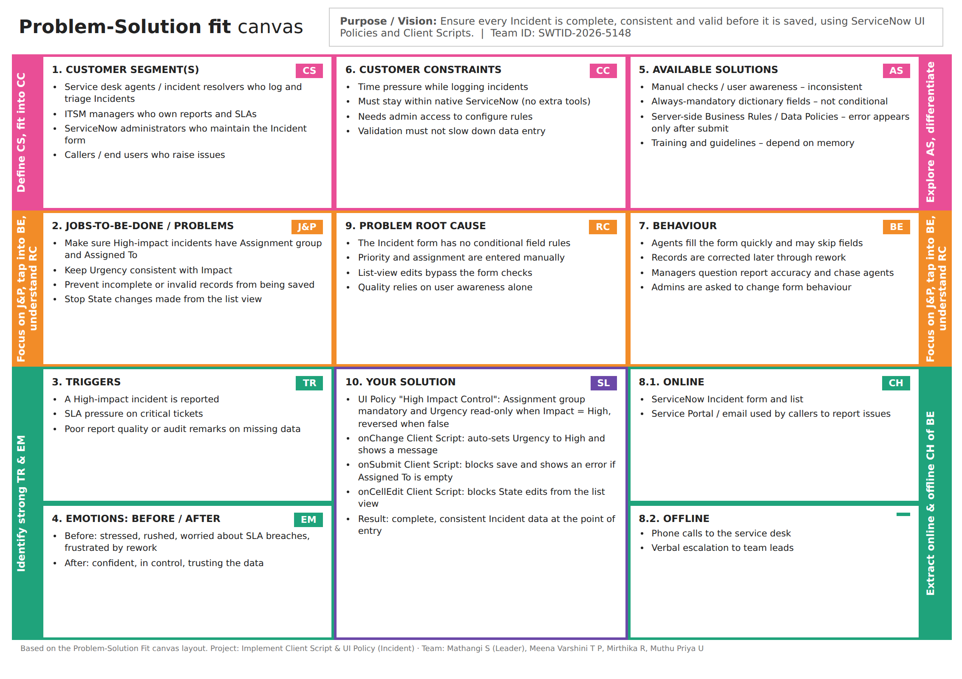
Figure 4.1: Problem-Solution Fit canvas

4.2 Proposed Solution
S.No. | Parameter | Description
1 | Problem Statement (Problem to be solved) | Incident records need consistent and accurate data for triage, routing and resolution, but relying on user awareness and manual checks leads to incomplete, inconsistent or incorrect data (for example a High-impact incident saved without an assignee or with a mismatched Urgency). This hurts reporting accuracy, SLA compliance and service quality.
2 | Idea / Solution description | Enforce data rules directly on the ServiceNow Incident form using UI Policies and Client Scripts. A UI Policy "High Impact Control" makes Assignment group mandatory and Urgency read-only when Impact = High (with Reverse if false). An onChange script auto-sets Urgency to High, an onSubmit script blocks saving when Assigned To is empty, and an onCellEdit script blocks State changes made from the list view.
3 | Novelty / Uniqueness | The solution combines a UI Policy and three types of Client Scripts (onChange, onSubmit, onCellEdit) in one lightweight, native ServiceNow configuration with no plugin or external tool. It validates at the point of entry, reverses automatically when conditions no longer apply, and also covers list editing, which form-only checks usually miss.
4 | Social Impact / Customer Satisfaction | Incidents reach the right team with complete details, which means faster resolution for callers, fewer SLA breaches and less rework for agents. Managers get more reliable reports, and administrators spend less time chasing data corrections.
5 | Business Model (Revenue Model) | This is a micro-project, not a commercial product. Its value is cost avoidance through less rework and fewer SLA penalties. It could be offered as a reusable configuration (update set) or as part of a ServiceNow implementation / support service.
6 | Scalability of the Solution | The rules are defined once on the Incident table and apply to all Incident records and users on the instance. The same pattern can be extended to other tables (Problem, Change), extra conditions or fields, and backed by a server-side Data Policy or Business Rule.

4.3 Solution Architecture
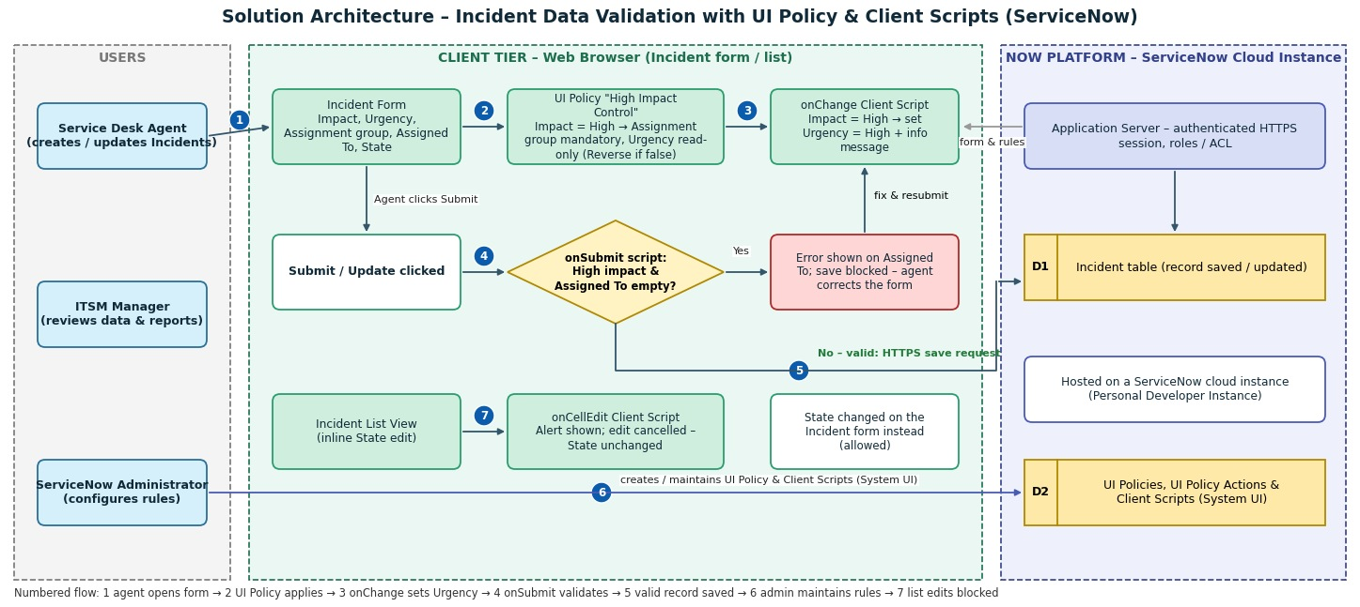
Figure 4.2: Architecture and data flow of the Incident Client Script & UI Policy solution
1. The service desk agent opens the Incident form in the browser; the form and the rules are delivered by the ServiceNow application server.
2. When Impact is set to High, the UI Policy makes Assignment group mandatory and Urgency read-only; Reverse if false restores the fields otherwise.
3. The onChange Client Script sets Urgency to High and shows an information message.
4. On Submit/Update, the onSubmit Client Script checks Assigned To; if it is empty for a High-impact incident, an error is shown and the save is blocked.
5. If validation passes, the record is saved to the Incident table through the application server.
6. The administrator creates and maintains the UI Policy, UI Policy Actions and Client Scripts in System UI.
7. If a user edits State directly in the list view, the onCellEdit Client Script shows an alert and cancels the change.

5. PROJECT PLANNING & SCHEDULING

5.1 Project Planning
Product backlog and sprint schedule (story points use the scale 1, 2, 3, 5):
Sprint | Functional Requirement (Epic) | User Story No. | User Story / Task | Story Points | Priority | Team Members
Sprint-1 | Incident Creation & Impact Handling | USN-1 | Set Impact to High so the system applies extra controls | 1 | High | Mathangi S
Sprint-1 |  | USN-2 | Provide Assignment group when Impact is High | 2 | High | Mathangi S
Sprint-1 |  | USN-3 | Urgency set automatically to High (onChange) | 2 | High | Mirthika R
Sprint-1 |  | USN-4 | Urgency read-only while Impact is High | 2 | Medium | Meena Varshini T P
Sprint-1 | Configuration | USN-11 | Create and activate the UI Policy and its actions | 3 | High | Mathangi S, Meena Varshini T P
Sprint-1 |  | USN-12 | Create the three Client Scripts | 3 | High | Mirthika R
Sprint-2 | Save Validation | USN-5 | Block save without Assigned To (onSubmit) | 3 | High | Mirthika R
Sprint-2 |  | USN-6 | Save succeeds once Assigned To is filled | 1 | High | Muthu Priya U
Sprint-2 | Reverse Behaviour | USN-7 | Controls removed when Impact changes from High to Medium | 2 | Medium | Meena Varshini T P
Sprint-2 | State Update | USN-8 | Change State on the Incident form | 1 | High | Muthu Priya U
Sprint-2 | Data Quality & Control | USN-9 | Block State edit in list (onCellEdit) | 3 | High | Mirthika R
Sprint-3 |  | USN-10 | Every High-impact incident has assignee and group | 2 | Medium | Mathangi S
Sprint-3 | Testing | USN-13 | Run test activities to confirm behaviours | 3 | Medium | Muthu Priya U, Mathangi S
Sprint-3 | Incident Submission | USN-14 | High-impact issue reaches support with complete details | 2 | Medium | Meena Varshini T P

Project tracker, velocity and burndown chart:
Sprint | Total Story Points | Duration | Sprint Start Date | Sprint End Date (Planned) | Story Points Completed (as on Planned End Date) | Sprint Release Date (Actual)
Sprint-1 | 13 | 6 Days | 05 Oct 2026 | 10 Oct 2026
Sprint-2 | 10 | 6 Days | 12 Oct 2026 | 17 Oct 2026
Sprint-3 | 7 | 6 Days | 19 Oct 2026 | 24 Oct 2026

Velocity: total story points = 13 + 10 + 7 = 30 over 3 sprints, so the team velocity is 30 / 3 = 10 story points per sprint. With a 6-day sprint, the average velocity per day is AV = velocity / sprint duration = 10 / 6 ≈ 1.67 story points per day.
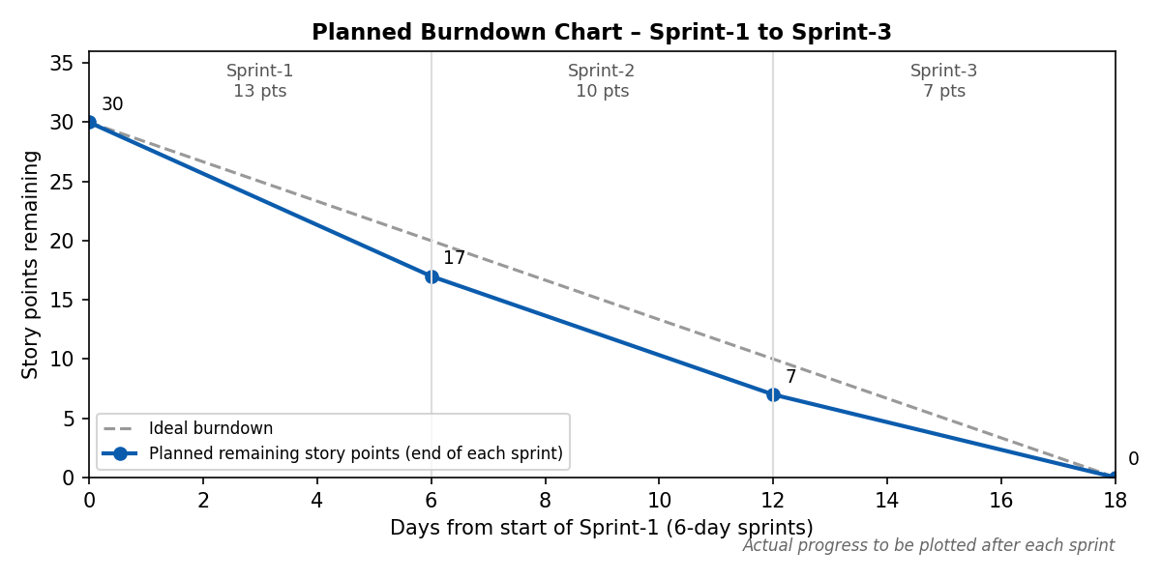
Figure 5.1: Planned burndown chart

6. FUNCTIONAL AND PERFORMANCE TESTING

6.1 Performance Testing
Functional (FT) and performance (PT) test cases were prepared for the UI Policy and the three Client Scripts. Actual results and Pass/Fail are recorded after execution on the ServiceNow instance. Performance targets are proposed limits for this lightweight client-side solution. User acceptance test cases (TC-001 to TC-012) are documented separately in the UAT report.
Test Case ID | Scenario | Test Steps | Expected Result | Actual Result | Pass/Fail
FT-01 | UI Policy – mandatory field (High impact) | Set Impact = High, leave Assignment group empty and submit | Assignment group is mandatory; form cannot be submitted without it |  | Pending
FT-02 | UI Policy Action – Urgency read-only | With Impact = High, try to change Urgency | Urgency is visible but read-only |  | Pending
FT-03 | onChange – auto-set Urgency | Change Impact to High | Urgency set to 1 – High with information message |  | Pending
FT-04 | onSubmit – block save | Impact = High, Assigned To empty, Submit | Record not saved; error shown on Assigned To |  | Pending
FT-05 | Successful save | Impact = High, fill Assignment group and Assigned To, Submit | Incident saved successfully |  | Pending
FT-06 | Reverse condition | Change Impact from High to Medium | Assignment group not mandatory, Urgency editable, record saves |  | Pending
FT-07 | Non-High impact behaviour | Impact = Medium/Low, Assigned To empty, Submit | Record saves normally |  | Pending
FT-08 | onCellEdit – list edit blocking | Double-click State in the list and change it | Alert shown; State unchanged |  | Pending
FT-09 | Form-based State update | Change State on the form and Update | State change saved |  | Pending
PT-01 | Client-side response time | Change Impact to High and time the Urgency update | Instant update (target under 1 second) |  | Pending
PT-02 | Save validation time | Submit with Assigned To empty and time the error | Error without server round trip (target under 1 second) |  | Pending
PT-03 | Form load time with scripts active | Open the form 10 times with scripts on and off | No noticeable increase (target under 0.5 second difference) |  | Pending
PT-04 | List view with many records | Open list with 50+ records and attempt several State edits | Alert each time; list stays responsive |  | Pending
PT-05 | Repeated use / multiple users | 3–4 members create and update High-impact incidents together | Rules work consistently with no slowdown |  | Pending

[ Attach screenshot here ]
Screenshots of executed functional test cases and results
Figure 6.1: Functional test execution evidence
[ Attach screenshot here ]
Timing results from the browser developer tools / stopwatch
Figure 6.2: Performance test evidence

7. RESULTS

7.1 Output Screenshots
Attach the screenshots below from your ServiceNow instance in the marked spaces.
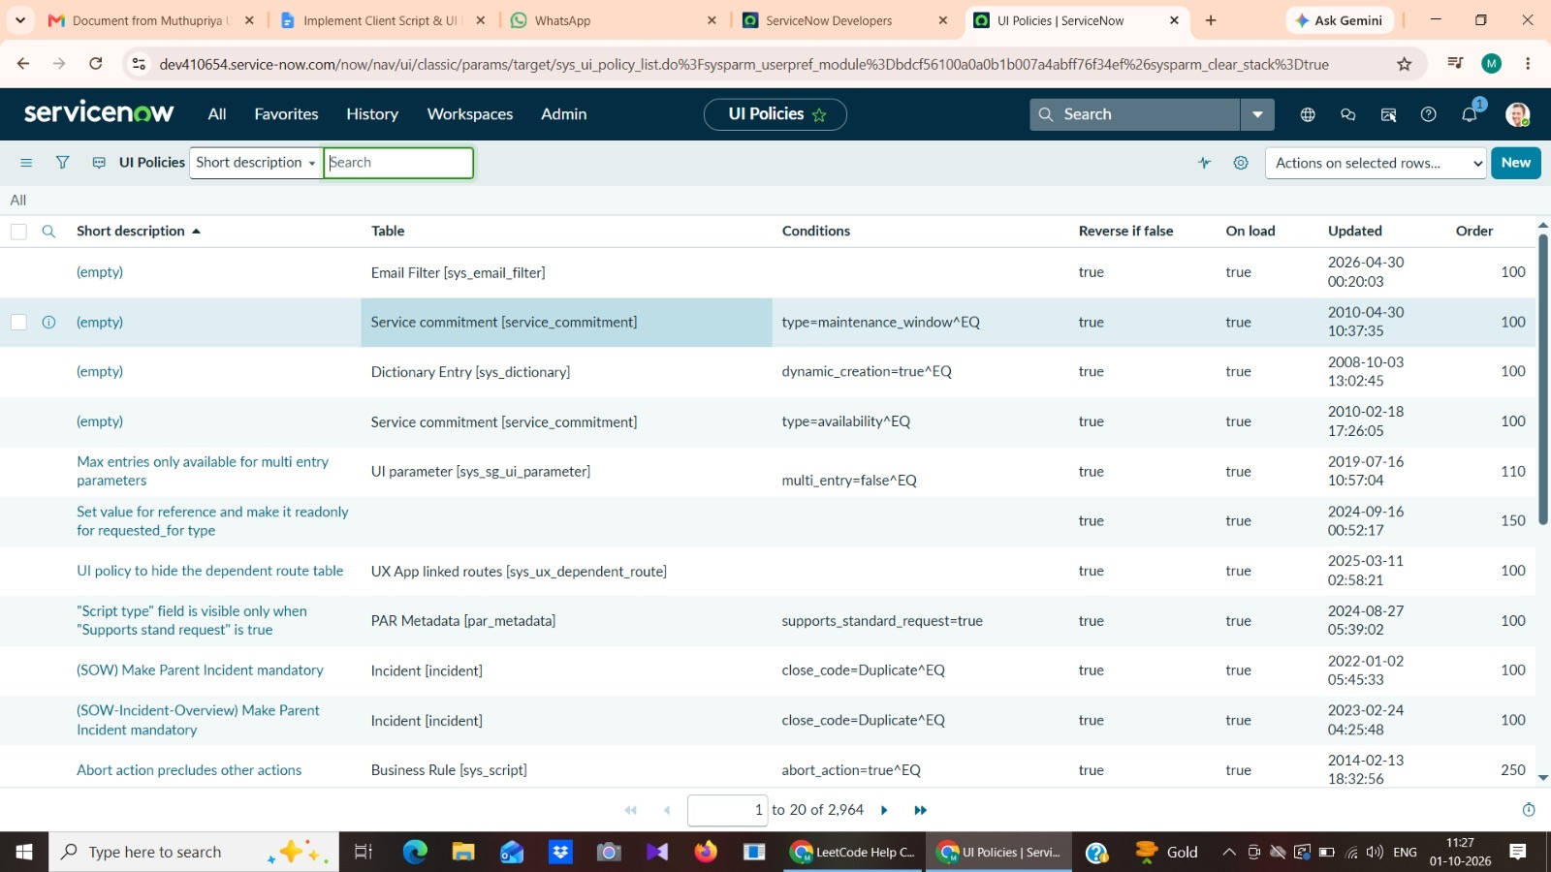
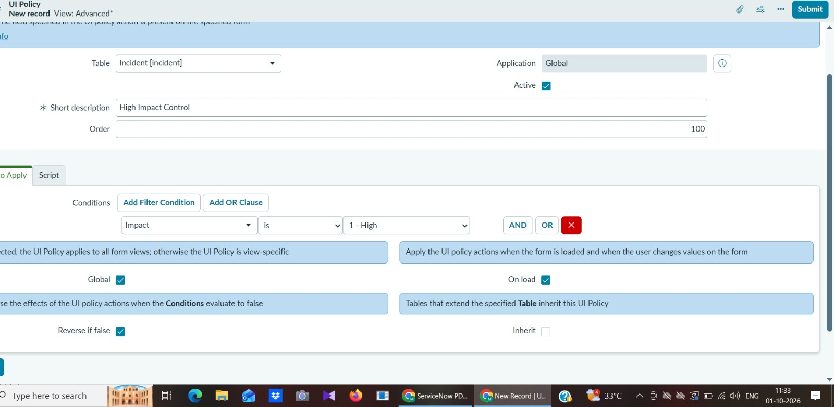
Figure 7.1: UI Policies list and the UI Policy "High Impact Control" configuration
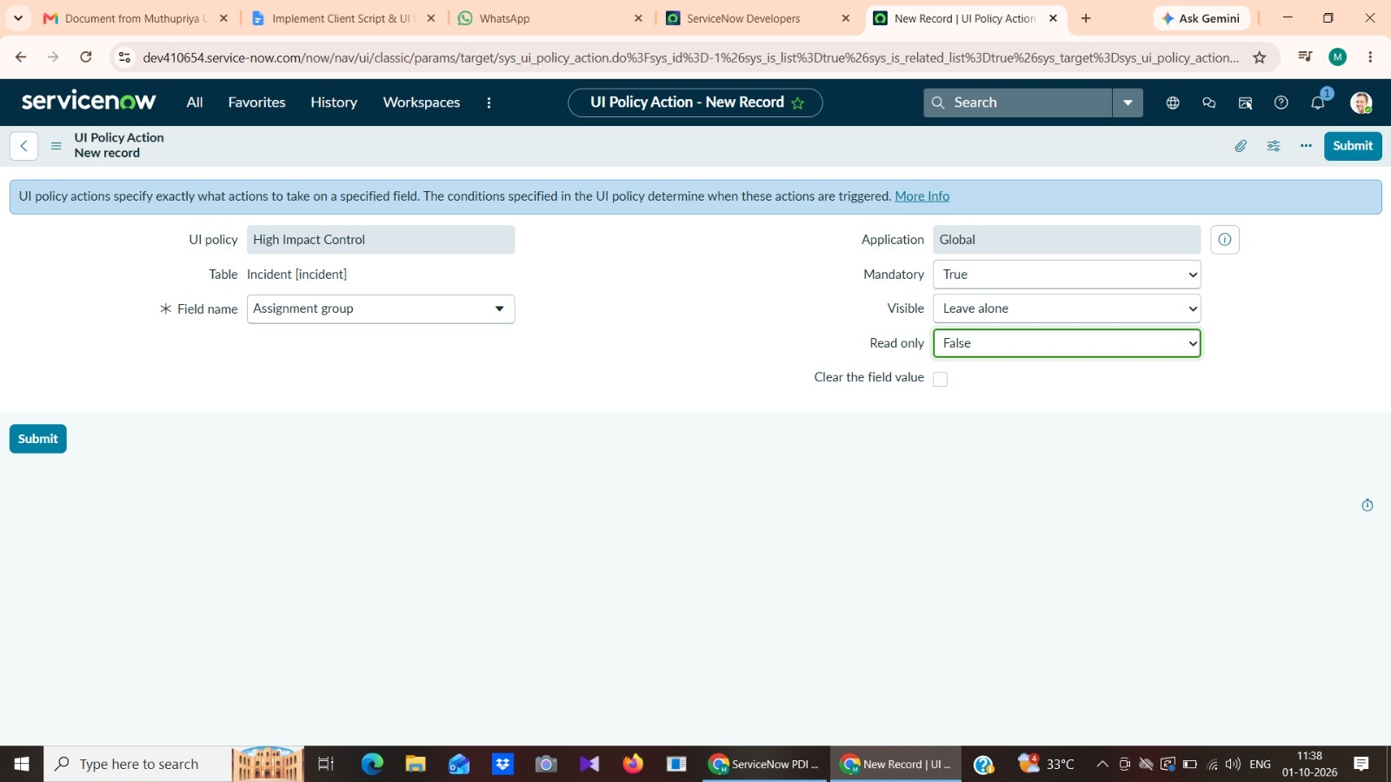
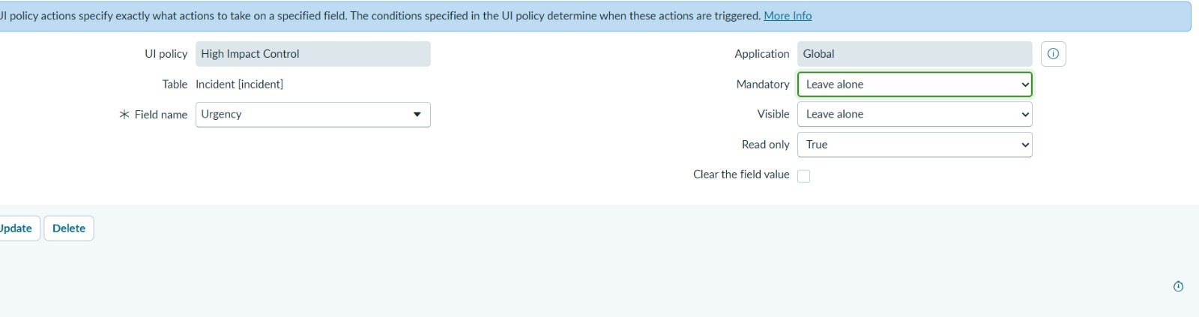
Figure 7.2: UI Policy Actions – Assignment group mandatory (top) and Urgency read-only (bottom)
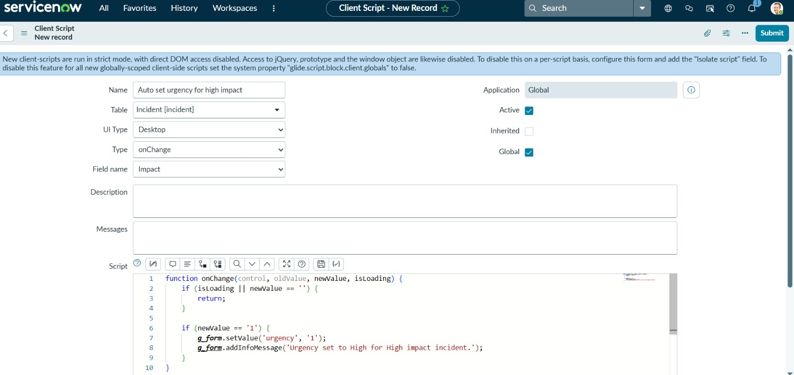
Figure 7.3: onChange Client Script
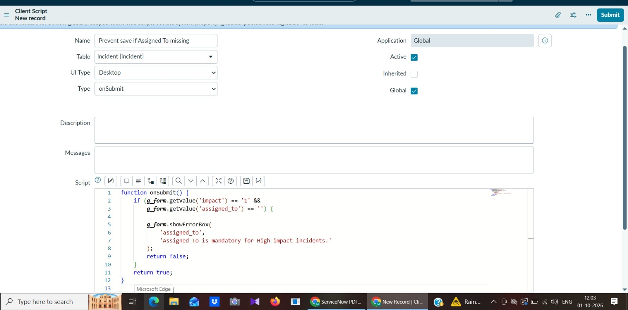
Figure 7.4: onSubmit Client Script
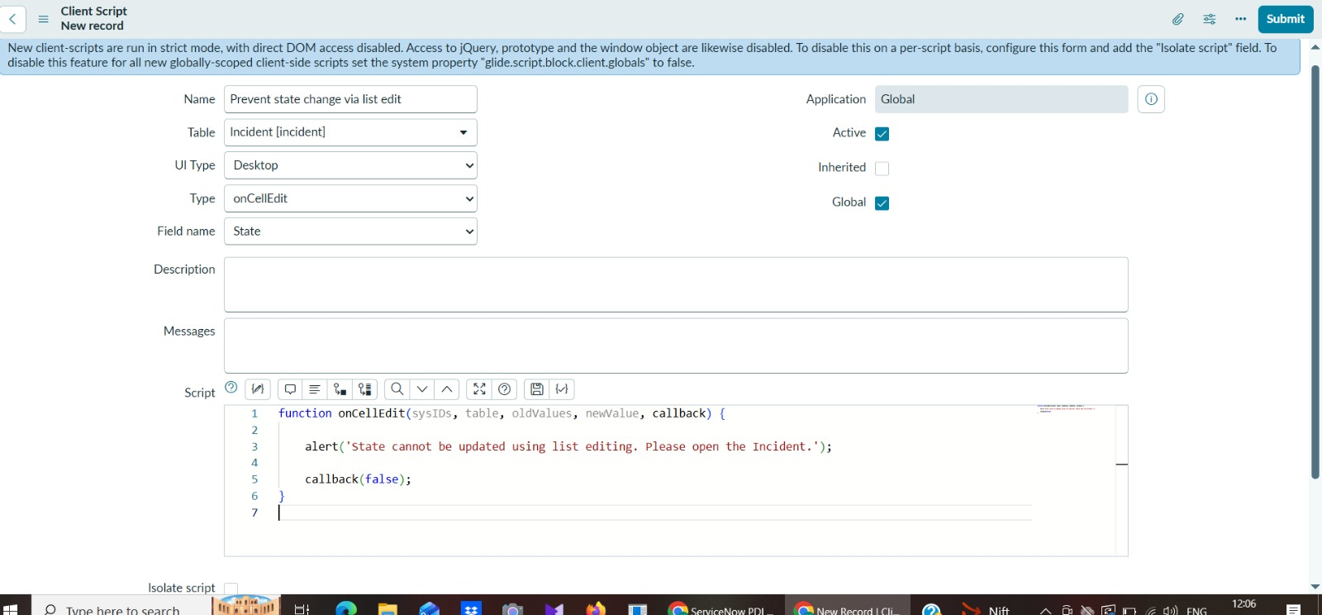
Figure 7.5: onCellEdit Client Script
[ Attach screenshot here ]
Incident form after selecting Impact = High
Figure 7.6: Impact = High – mandatory Assignment group, read-only Urgency, auto-set Urgency message
[ Attach screenshot here ]
Error message shown on the field
Figure 7.7: Save blocked with error on Assigned To
[ Attach screenshot here ]
Record saved without errors
Figure 7.8: Successful save of a valid High-impact Incident
[ Attach screenshot here ]
Fields editable again
Figure 7.9: Reverse condition – Impact changed from High to Medium
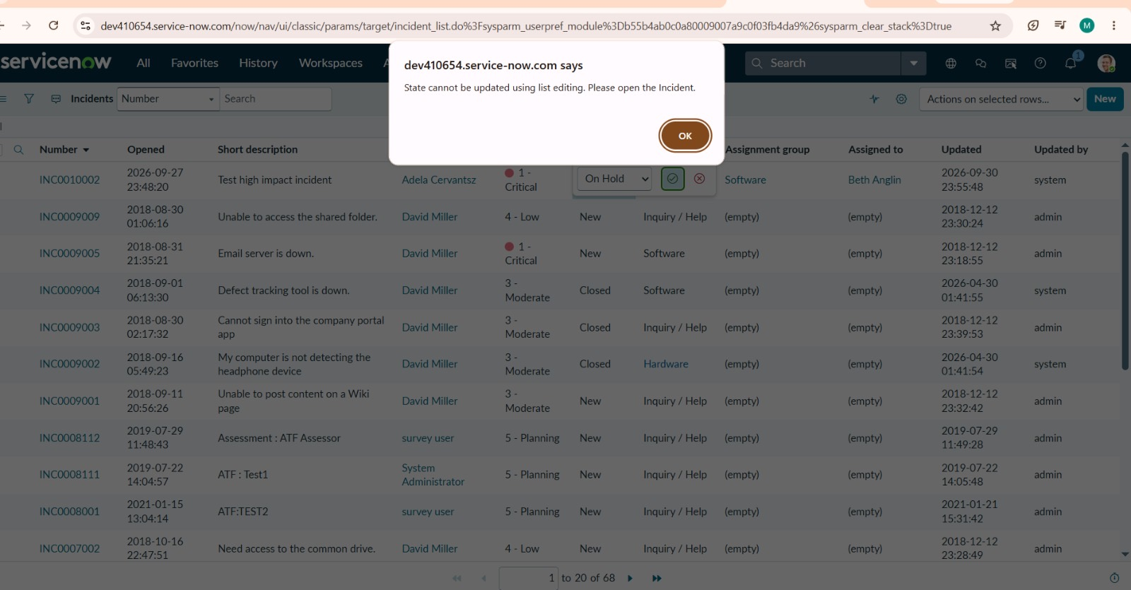
Figure 7.10: List-edit of State blocked with alert
[ Attach screenshot here ]
State changed on the form and updated
Figure 7.11: Form-based State update succeeds

8. ADVANTAGES & DISADVANTAGES
Advantages
• Enforces complete and valid data at the point of entry, before the record is saved.
• Lightweight and fast, because the checks run in the browser without extra server calls.
• Uses native ServiceNow features only; no plugins or external tools are needed.
• Rules reverse automatically when conditions no longer apply (Reverse if false).
• Defined once on the Incident table and applied to all users and records.
• Reduces rework, improves SLA compliance and makes reports more reliable.
Disadvantages
• Client-side rules do not apply to data loaded through imports or integrations, so they do not replace server-side enforcement.
• Urgency is not reset when Impact is lowered from High.
• Two different rules (Assignment group mandatory in the UI Policy, Assigned To checked on submit) may confuse users.
• The list-edit block uses a browser alert() pop-up instead of an on-form message.
• Scripts need to be maintained by an administrator when business rules change.

9. CONCLUSION
The Implement Client Script & UI Policy (Incident) project demonstrates how UI Policies and Client Scripts work together to enforce dynamic field behaviour, automate updates and prevent incorrect data submission on Incident forms. By using onChange, onSubmit and onCellEdit scripts alongside UI Policy actions, the project ensures that fields such as Assigned To, Assignment group and Urgency respond appropriately to changes in Impact, keeping data clean and consistent. The solution enforces mandatory fields and controls user interactions while remaining lightweight, efficient and easy to implement, making it well suited to a short micro project and showing practical ways to improve form usability and data integrity in ServiceNow.

10. FUTURE SCOPE
• Add a server-side Data Policy or Business Rule as a backup so that imports and integrations are also validated.
• Reset Urgency when Impact is lowered and show all missing-field errors in one message.
• Replace the alert() pop-up with an on-form message.
• Add an ACL or bulk-update guard on the State field and notify the manager when a High-impact incident is created.
• Add an SLA warning banner on the form and a dashboard for High-impact data quality.
• Extend the same approach to other tables such as Problem and Change.

11. APPENDIX
Source Code
onChange Client Script – Auto set urgency for high impact (Table: Incident, Field name: Impact)
function onChange(control, oldValue, newValue, isLoading) {
if (isLoading || newValue == '') {
return;
}
if (newValue == '1') {
g_form.setValue('urgency', '1');
g_form.addInfoMessage('Urgency set to High for High impact incident.');
}
}

onSubmit Client Script – Prevent save if Assigned To missing (Table: Incident)
function onSubmit() {
if (g_form.getValue('impact') == '1' &&
g_form.getValue('assigned_to') == '') {
g_form.showErrorBox(
'assigned_to',
'Assigned To is mandatory for High impact incidents.'
);
return false;
}
return true;
}

onCellEdit Client Script – Prevent state change via list edit (Table: Incident, Field name: State)
function onCellEdit(sysIDs, table, oldValues, newValue, callback) {
alert('State cannot be updated using list editing. Please open the Incident.');
callback(false);
}

Dataset Link
Not applicable – the project works on the Incident table of the ServiceNow instance and uses no external dataset.
GitHub & Project Demo Link
GitHub: [add your GitHub link here]
Project demo: [add your demo link here]

